STAR CLINICAL PROTOCOL

Effective STAR pathway implementation and design of the ‘STAR toolkit’

This clinical protocol is designed to complement the study protocol of the STAR study and focus on the clinical aspect of the study alone.

Table of Contents
1. OVERALL PATHWAY 3
2. ELIGIBILITY FOR STAR 4
3. PRE-OPERATIVE ARRANGEMENTS 4
4. EVAR SCHOOL 6
5. SURGERY 7
6. FOLLOW-UP ARRANGEMENTS 7
7. OPERATIVE TIMELINE AND CHECK-LIST 9

OVERALL PATHWAY
Vascular Clinic
- Initial decision for open repair or EVAR

48-Hour check
- CNS phone call (see page 7)
EVAR
(see page 9)

Follow standard treatment pathway
CNS remote consultation
- EVAR “school” (see page 6)
- Medication review
- Assessment of social circumstances inc. transportation
Remote POA
- By Vascular Nurse & Anaesthetist
- Review of clinical data
- Systems enquiry
Vascular MDT
- Eligible for 23-hour pathway? (see page 3)
Pre-op work-up
- Bloods including group and save
- Assessment of cardiac and respiratory function
- Medication review
NO
Screening for infections
- MRSA, CPE, COVID test
- 72 hrs prior to procedure by Vascular CNS

ELIGIBILITY FOR STAR

INCLUSION CRITERIA | EXCLUSION CRITERIA
Standard, infrarenal EVAR procedure on IFU | Significant cardiac disease*
Age >55 | Significant Renal Disease**
Fully independent at home (or adequate provision for home care after discharge) | Significant respiratory disease***
Living with a partner or family member or having similar help available for the first 24-hours after discharge | Any other condition, which in the opinion of the multidisciplinary team makes discharge within 23-hours unsafe
Transport to attend the hospital in which they were treated within 1 hour for the first 24-hours after discharge | Lack of capacity to consent
Able to comply with protocol requirements and discharge | Concurrent enrolment in another drug or medical device study
Signed informed consent form for patient participation in the study
*Defined as one or more major predictors of increased perioperative cardiovascular risk according to the American College of Cardiology Cardiac Risk Classification, which remain untreated.
**Defined as a pre-op Creatinine >150 μmol/L or eGFR<30 mL/min/1.73m2
*** Patient requiring increased post-operative care not available in the home environment (e.g., nebulisers or oxygen therapy which is not set-up at home)

PRE-OPERATIVE ARRANGEMENTS

The following aspects of care will not be changed but will be recorded in the screening log:
- Assessment of AAA
- MDT discussion
- Decision to operate and decisions on EVAR vs open repair
- Cardiorespiratory work up programme

The participant will be consented at a pre-operative visit which might be:
- Pre-assessment
- Routine clinic visit
- Anaesthetic pre-assessment

The pathway is initiated once a patient has consented for the STAR study.

- The participant should be given information including:
  - Patient information leaflet
  - Informative short video clips
  - Site specific introductions to staff and ward familiarisation

- Prior to surgery, the following should be advised/completed:
  - Medicines optimisation - offered secondary prevention therapy with an antiplatelet and statin in line with NICE guidance, if applicable (NICE NG156, 2020).
  - Smoking cessation
  - Alcohol advice
  - Nutritional advice
  - Pre-habilitation exercises
    - Standardised
    - Self-directed
    - Utilising NHS apps and information already available
    - Aligning with the Frailty guide from the British Geriatric Society.
  - Social arrangements clearly set out for after the operation.
  - Cognitive impairment screening and appropriate actions from the results of this.
- The GP should be informed that the participant is taking part in the study. GPs will be informed of the study and sent site specific information after each patient is recruited. The GP letter will contain a link to informative short video links which will be created.
- The vascular CNS will conduct an in-person or phone consultation after consent. This serves the purpose of establishing a rapport with the patient, to gauge their willingness and understanding of this process, and to establish their social background. The latter point is of particular importance since some patients may need considerable help with their discharge planning arrangements. Note the participant must live within a reasonable distance from the hospital for any complications to be addressed quickly; and the participant must also be living with another adult who can look after them in the initial 48-hour postoperative period. The vascular CNS will provide advice regarding isolation periods and conduct a second review of the patient’s current medication, to identify if appropriate medicines optimisation has occurred or remains outstanding and to ensure that any pre-operative anticoagulation plan is implemented

Infection screens to include swabbing for MRSA, CPE and SARS-CoV-2, and mandatory self-isolation periods should continue as per hospital policy.

EVAR SCHOOL

The participant will start EVAR SCHOOL prior to admission for 23-hour EVAR. This is to ensure patient engagement throughout the pathway.

- It is a protocolised patient focussed series of goals that the participants will ensure occur during their patient journey.
- Pre-operative aims, post-operative goals in-hospital and instructions on what is important at home in the first 48-hours are all included.
- A patient checklist of items that need to have been completed at each stage of the patient journey.

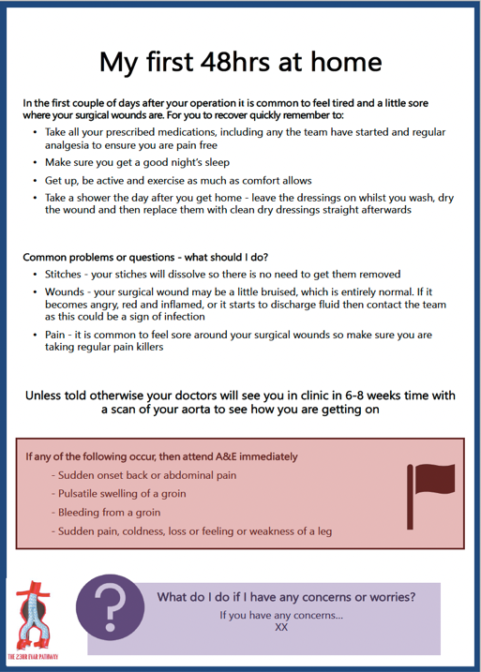
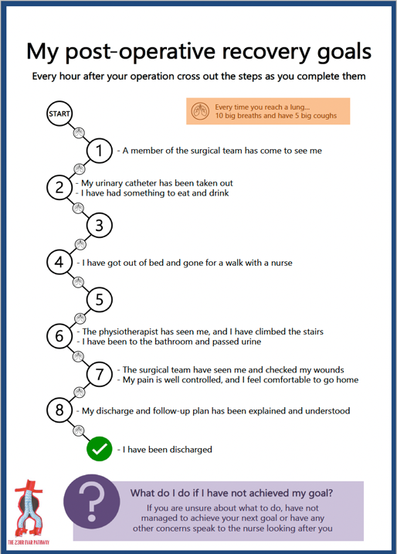
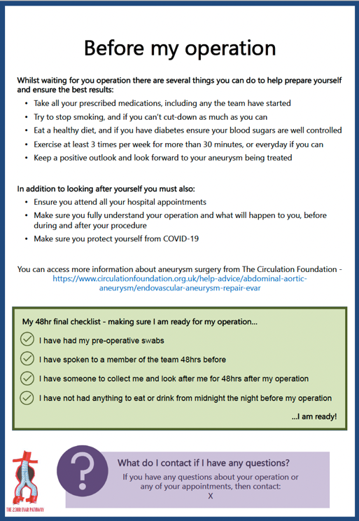


SURGERY

- The participant will attend the hospital on the day of surgery.
- On admission (day 0):
- The participant will be admitted (administrative and medical admission).
- The progress with preparations for 23-hour EVAR will be checked.
- Throughout the inpatient stay, Case Report Form (CRF) 2 will be filled out.

The surgery will be performed according to local protocols and there will be no change as a result of the study. Although local/regional anaesthesia techniques and percutaneous access will be preferred there is no exclusion if other methods are used if in the opinion of the surgical team the participant is still a candidate for the 23-hour EVAR pathway.

The recovery destination of the participant will follow local protocols.

- A protocol-driven pathway for post-operative care will be used to encourage early rehabilitation. In the recovery area, the participant is nursed:
  - Post-operative review by the surgical team occurs
  - Bloods checked to ensure haemoglobin, electrolytes within acceptable limits.
- Removal of arterial line, CVP line and urinary catheter if relevant
- If a spinal catheter has been inserted, it should be removed no less than 3 h after the end of the procedure. The need for this may alter the timeline of discharge from Recovery to the ward, as the patient must have catheter removed in Recovery.
- If ultrasound of the groin is required after percutaneous closure this will be arranged at this point.

- On return to the ward (day 0) the following should be achieved:
- Mobilisation
- Eating and drinking
- Discharge summaries written
- Medication prepared as a pre-pack, so this is routinely available from early morning
- Review in evening and intentions for discharge the next morning confirmed.

- On the morning of day 1:
- Assuming there are no complications from surgery, the patient will be deemed medically fit for discharge after surgical review.
- The Vascular Nurse specialist or designated clinician who is to follow-up the patient will ensure discharge plans are in place utilizing specifically agreed protocols.

FOLLOW-UP ARRANGEMENTS

- Phone consultation: A phone consultation is to be conducted by the Vascular CNS 48- hours following discharge. In addition to a general enquiry and review of medications, the CNS will enquire about:
- Any pain
- Eating and drinking
- Any difficulties with walking or mobilisation
- Whether the patient has been able to open bowels and pass urine
- New onset chest pain
- New onset shortness of breath
- Wounds and new onset swelling in the groin access site
- New onset urinary symptoms
- Whether the GP or Accident and Emergency service has been consulted and whether any treatment given
- Other issues.
- Fill in CRF 3 and relevant questionnaire

- Follow up: The study requires participants to undergo an imaging check and follow up appointment at 30 days +/-14 days, which is standard in most trusts. At this appointment additional information will be asked of the participant and CRF 4 with the relevant questionnaires should be filled in.

- The study requires the participants to undergo a telephone follow up at 3 and 6 months. At this appointment additional information will be asked of the participant. This is not considered standard of care. At this stage CRF 5 (3 months) and CRF 6 (6 months), with the relevant questionnaires should be filled in.

- The study requires participants to undergo an imaging check and follow up appointment at 1 year, which is standard in most trusts. At this appointment no additional information will be asked of the participant, but clinical information will be collected by the study team. Please complete CRF 7. At this stage, there will be no questionnaires administered.

- Throughout data on readmission, reoperation, adverse events and costs will be collected.

OPERATIVE TIMELINE AND CHECK-LIST
TIMING
DAY 0
PATIENT ARRIVAL
- Observations
- Consent (Vascular SpR)
- Cannula and bloodwork (2nd G+S)
- Anaesthetic Review
TEAM BRIEF
- Vascular Team
- IR Team
- Anaesthetic Team
- ODP
- Scrub Staff
- Runner
PATIENT INTO ANAESTHETIC ROOM (CLOCK STARTS)
- WHO sign in
- Antibiotic prophylaxis: teicoplanin 10mg/kg IV, gentamicin 5 mg/kg IV
- Ward team to start discharge summary
- Ward team to chart regular medication
- Arterial line insertion
PATIENT INTO OPERATIVE ROOM
- Patient preparation
- WHO checklist (Time Out)
- Sterile preparation
- Urinary catheter (preferably convene if suitable)
EVAR performed
- WHO checklist (Sign Out)
PATIENT INTO RECOVERY
- Surgical review
- Groin check and USS of groin, if indicated
- Anaesthetic review
- Remove arterial line
- Remove catheter
- Encourage intake of food and drink
TRANSFER TO WARD
- Mobilise with nurse
- Nurse to flag with theatre team if not walking and eating and drinking
PHYSIO ASSESSMENT (if needed)
- Longer walk/stairs
- Encourage the use of EVAR School checklist
- Check that the patient has passed urine?
COMPLETION OF DISCHARGE SUMMARY
- Is the patient safe to be discharged this evening? (achieved the below):
  - Pain is controlled?
  - Groins satisfactory?
  - Eating and drinking?
  - Mobilised?
  - Passed Urine?
  - If yes, continue with Day 1 plan (below) this evening
DAY 1
ADMINISTER PRE-PACK
- Analgesic and laxative package: co-codamol 30/500 mg, one or two tablets QDS PRN, lactulose 15 ml BD, 7.5 mg OD
- Patient supplied with water-proof dressings for 7 days)
FINAL REVIEW BY OPERATING SURGEON AND DISCHARGE (CLOCK STOPS)

