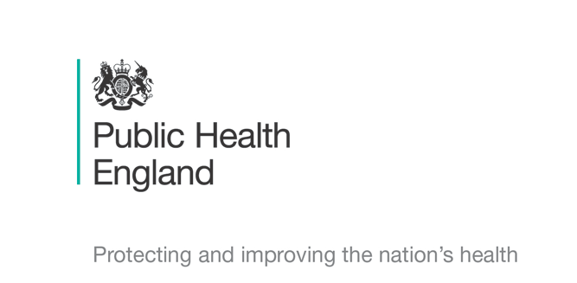



Principal Investigator
Dr Rebecca Cordery
Chief Investigator
Prof Shiranee Sriskandan

Schools Transmission Study : COVID-19
Information leaflet and Assent form for cases of coronavirus- Children aged under 8


Today we are finding out about a germ called coronavirus that can make children sick. Please read this with mummy and daddy or your guardian.

Most germs can live in your nose and throat without making you ill.

The doctors and nurses want to know what germs live in your nose and throat and on your hands and have asked your mummy and daddy or guardian if it is OK to find out.

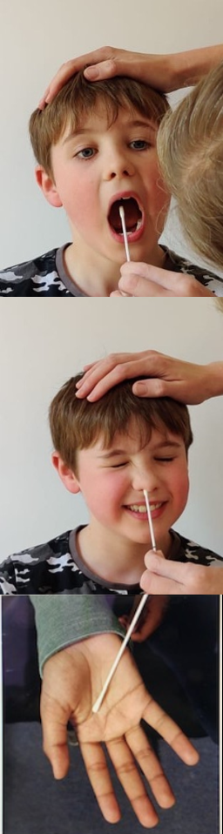
The nurse will ask you to open your mouth wide like this so they can take a throat swab. It’s a bit ticklish. They will also take a swab from inside your cheek, your nostril and from one of your hands. They will also ask you to spit into a pot.

If your parents or guardian are OK with it, the nurse will come back next week to see you again.

The nurse will also ask your mummy and daddy or guardian some questions about how ill you have been and whether you are getting better. The nurse might ask your mummy and daddy or guardian to collect a sample of your poo in a pot.

When they visit they might also ask you to talk or sing while they collect air samples!

Ask your mummy and daddy or your guardian if you have any questions.

Coronavirus Study: Assent Form for Children with Coronavirus aged under 8

Please keep this section for your own records

Please circle the Thumbs Up/Yes if you agree.
If you don’t agree, please circle the Thumbs Down/No boxes.

- Did you look at the leaflet with your parents or guardian? | Yes   |  | No  
- Do you know what the study is for? | Yes |  | No
- Are you OK take part and have the swabs? | Yes |  | No
If you do want to take part, you can write your name below
Your Name ……………………………. Your Age…………….
Date …………………………….

The nurse or doctor running the study needs to sign here too

Research team member name ………………………………….

Signature …………………………………….. Date…………………

Thank you for your time

Coronavirus Study: Assent Form for Children with Coronavirus aged under 8

Please complete and tear off- Return to the Study Nurse as soon as possible

Please circle the Thumbs Up/Yes if you agree.
If you don’t agree, please circle the Thumbs Down/No boxes.

- Did you look at the leaflet with your parents or guardian? | Yes |  | No
- Do you know what the study is for? | Yes |  | No
- Are you OK take part and have the swabs? | Yes |  | No
If you do want to take part, you can write your name below
Your Name ……………………………. Your Age…………….
Date …………………………….

The nurse or doctor running the study needs to sign here too

Research team member name ………………………………….

Signature …………………………………….. Date…………………

This section to be returned to the study nurse

