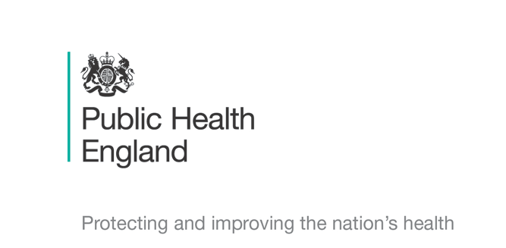


Principal Investigators
Professor Shiranee Sriskandan Dr Rebecca Cordery & Dr Miranda Mindlin
Chief Investigator
Prof Shiranee Sriskandan

Schools Transmission Study : COVID-19
Parent/Guardian Information leaflet for cases of Coronavirus

We are asking for your child’s help in a research study to help us find the best ways of reducing the spread of coronavirus. Please take time to read this leaflet and ask us if anything is not clear, or if you need a translation. If you are happy for your child to take part please sign the consent form at the end and return it to the study team by hand or by email/text by tomorrow morning if possible. You can also text an image of the consent form to our study phone. Please keep a copy of this leaflet for your records.

What is the purpose of the study? We want to know how long the coronavirus can be found in children’s nose, throat and skin during their illness and when they are better. We also want to know how easy it is for the virus to spread, particularly when children are not showing any symptoms of illness. This information will help us to ensure that the best advice is provided to families, schools, and doctors. It’s therefore important for us to start the study as soon as possible after the diagnosis is suspected. We would also like to know more about the impact of your child’s illness on your child and on you, including how quickly they get better if they have been unwell.

Why have we been chosen? We have contacted you because your child has tested positive for coronavirus. We would like to ask your child to provide samples. We are also interested in finding out if coronavirus is found on surfaces and in the air so would like to take some samples in your home.

Does my child have to take part? No- taking part is entirely voluntary and does not affect any part of your child’s routine care. If you agree to take part but then change your mind please just contact us, using the information below, to say that you no longer wish your child to take part.

What will happen to my child if they take part? We would like to take a throat swab, a nose swab, a gum swab and a hand swab from your child today (or as soon as possible) and then on four more days over the next two weeks (5 visits in total over the first two weeks), and then once a week for two more weeks. These samples will take about two minutes to collect. We would also like to collect a saliva (spit) sample. The specialist will visit at a time arranged with you to take the samples at home; they will use PPE (protective equipment) but will be discrete. When your child returns to nursery or school, the specialist can take the samples there. If it is possible we would like to have a sample of stool (poo) from your child. We will provide a pot and instructions for this and collect it on the next occasion we visit.

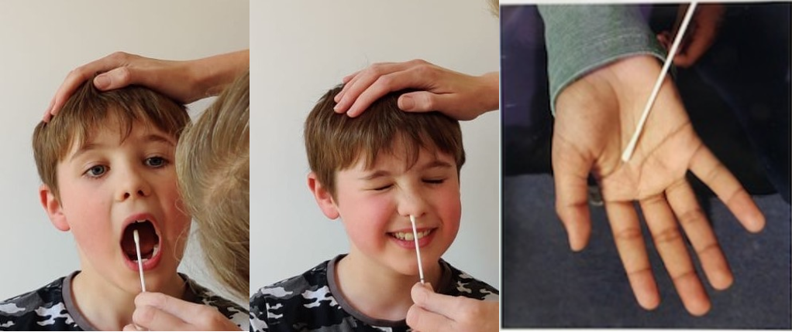
The throat swab is rather like a cotton bud; your child will be asked to open their mouth wide and the public health specialist will quickly rub the swab around the back of the mouth and tonsils. The process can feel a bit ticklish; some people find that it makes them cough but these feelings are over in an instant. Another swab will be rubbed just inside the nostril, another on the side of the gums (that your child can do themselves), and another on your child’s hands.

If your child has already had a swab and it was positive please tell us: we would like your consent to contact the local laboratory so we can include that sample in the study. Your doctor will still have access to the results. This will not affect any part of your child’s treatment. Even if your child has already had a swab, we would still like to collect the follow up swabs.

Samples from around the home. If you are agreeable we will take some swabs from door handles and toys or gadgets that are used by your child around the house, and also environmental air using an air sampler. We would like to take samples of air from the same room as your child, using an air sampler (which is like a small fan heater), and will ask your child to do an activity such as reading aloud, singing or shouting! We may even ask your child to wear a face mask that can capture their breath rather than the air sampler- this would allow us to sample your child’s breath more effectively. These samples take about 30 minutes to collect.

What will I have to do? If you are happy for your child to take part please sign the consent form at the end and return it to the public health specialist, keeping one copy of the leaflet for your records. Please look at the leaflet given to your child and ask them to give assent for the study in the special section at the end of their leaflet. If your child returns to school and you would like to be present when they have a swab, this can be arranged but it is not necessary.. Because COVID-19 is notifiable, you may be/may have been asked to complete an online questionnaire by Public Health England about your child’s illness; we would like your permission for us to link your questionnaire to your child’s samples.

What are the risks/benefits of taking part? Throat and nostril swabs can feel a bit ticklish; some people find that it makes them cough but these feelings are over in an instant. If you are being asked to self-swab your child there is no risk from the procedure when the guidance is followed. The swabs will then be sent to a laboratory to be tested for COVID-19.

WiIl taking part in this study be kept confidential? Yes, your participation in the study and all test results will be confidential. Only our NHS and PHE specialists will have the details that you provide. Any research will be done using codes and not your personal details. For more information about how we look after your data please visit https://www.imperial.ac.uk/medicine/hpru-amr/patient-and-public-information/schools-transmission

What will happen to the results of the study? You will be notified of your child’s first test result from the study but this will not alter the original test result that your child already has.. We will not be able to feedback the results of the follow up samples as these will be processed in batches using codes. We will not test for anything other than the virus that causes coronavirus disease (SARS-CoV-2) and a small number of other microbes, and antibodies. All the swabs will be discarded once testing has been completed. At the end of the study we will provide general feedback to the school/nursery for you. If you would like a copy of any published report please contact us or check on the study website (above).

Who is organizing and funding the research? The research is being done by Public Health England together with Imperial College London and funded by UKRI. The investigators are Prof. Shiranee Sriskandan (Imperial College) and Dr Rebecca Cordery plus Dr Miranda Mindlin (Public Health England). The contact details for the team are given below

Who has reviewed the study? The research has been reviewed by academic reviewers and by a nationally-appointed independent NHS research ethics panel of experts and lay people.

What if something goes wrong? If your child becomes more unwell during the study, you should consult your General Practitioner (GP) as normal. The results from the study will not help your GP decide how to treat your child; they will manage your child as they would do normally.
Although we do not expect any adverse problems, Imperial College London holds insurance policies which apply to this study. If you experience harm or injury as a result of taking part in this study, you will be eligible to claim compensation without having to prove that Imperial College is at fault. This does not affect your legal rights to seek compensation. If you are harmed due to someone’s negligence, then you may have grounds for a legal action. Regardless of this, if you wish to complain, or have any concerns about any aspect of the way you have been treated during the course of this study then you should immediately inform the Investigator (Shiranee Sriskandan s.sriskandan@imperial.ac.uk). The normal National Health Service complaints mechanisms are also available to you. If you are still not satisfied with the response, you may contact the Imperial AHSC Joint Research Compliance Office.
The contact details for the study team are: TraCK Study Team Telephone 07597 510347 Email ramlah.junaideen@nhs.net
Copy of Miniconsent for your Records

Consent Form -Parent/Guardian of cases of Coronavirus
Please return this as soon as possible to the Public Health Specialist
You can send an image of the completed form to Email ramlah.junaideen@nhs.net or by text or whatsapp to Telephone 07597 510347

Study Title: Schools Transmission Study : COVID-19
Principal Investigators: Dr Rebecca Cordery, Dr Miranda Mindlin, Public Health England, Professor Shiranee Sriskandan (Imperial College London)
Chief Investigator: Prof Shiranee Sriskandan

Parent/Guardian Consent Form

Child’s name ……………………………………………….Child’s age …………….

Parent/guardian contact number ………………………………………………

Please initial the following boxes if you agree:

I have read the Information Leaflet and understand its contents. I have had an opportunity to ask questions

I understand that my child’s involvement is voluntary and I am free to withdraw at any time without giving any reason and without my child’s care or legal rights being affected.

I agree for my child to take part in the study and have samples taken on 5 days over weeks 1 and 2 and once weekly samples after that for two more weeks

I agree for the research team to retrieve the result from any previous swab and questionnaire

I agree for the research team to collect air and surface samples from my home

Please delete as appropriate
When they return to school/nursery, I do not need/do need to be present when my child has their swabs taken
If you wish to be present please let the research team know when you would be available
(We will try to accommodate all requests but if it is not possible then we will not include your child on those occasions)………………………………..

Name of Parent or Guardian ………………………………….

Signed …………………………………….. Date……………

(For Study team only)
Name of Specialist taking consent……………………………………………………….
Signed ………………………………………Date…………………

