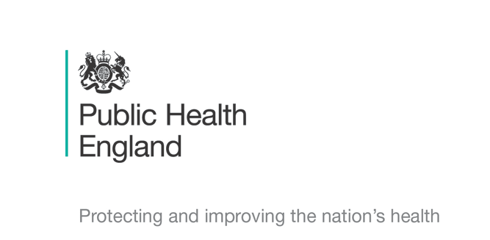


Principal Investigators
Prof Shiranee Sriskandan Dr Rebecca Cordery & Dr Miranda Mindlin
Chief Investigator
Prof Shiranee Sriskandan

Schools Transmission Study : COVID-19
Information Leaflet and Assent form for Contacts aged over 8

We would like to ask you to take part in some research about COVID-19. Please read this with your parents or guardian so you can decide if you want to take part. They should have a longer leaflet to read too.

What’s the research about? It’s about the coronavirus which causes COVID-19, an infection you will have heard about on the news. We need to know if the coronavirus can be found in young people who have been in contact with others who do have the virus, even in those who don’t have any symptoms of COVID-19. It can help us to work out if it spreads from person to person.

Does everyone have to take part? It’s completely up to you if you take part - just tell your parents or guardian – or the nurse doing the research - if you do not want to. You have been chosen because you are especially important to the research, however. You can change your mind at any time If you are OK to take part, please fill out the form at the end of this leaflet..Your parent or guardian also needs to complete a consent form.

What happens if I do take part?
If you are in a class that has been asked to isolate at home, your parent or guardian will be asked to take a swab of your throat and nostril which will be tested for coronavirus. You can see how these are done in the photo. If it’s easier, the study nurse can do this- or you can do it. We will also ask you to take a gum swab using a foam ‘lollipop’ stick. This all takes less than 2 minutes. The team will bring the kit to your front door and wait till the sample is taken. If you have been asked to isolate at home by the school, we will ask you to have the swabs on 3 occasions (weekly)- we can complete the swabs when you return to school.
If you are in a class that has not been asked to isolate, we can do all the swabs in school on 1, 2, or 3 weekly occasions. We might also ask you for a saliva (spit) sample and take a hand swab.

What are swabs like? Throat swabs can feel a bit ticklish; some people find that it makes them cough but most people are fine. Nostril swabs are not painful but can feel ticklish too.

Will taking part help me or anyone else? Taking part can’t help you directly, but if all the people invited do take part, the research we do should give us answers that will help us reduce the risk of COVID-19 spreading from person to person. So you would be helping other children and young people in the future and protecting families.

Will anyone else know I am taking part in the study? Only you, your parents or guardian, and the public health team doing the research will know. If you are in school, the school leaders will help us It’s up to you if you tell your friends you are taking part. Everything is kept private.

Who is doing the research and is it OK to do it? The study is being done by teams at Public Health England and Imperial College London, and has been checked to see that it is run properly.
The team running the study can be contacted-
TraCK Study Telephone 07597 510347 Email XXX@nhs.net
If you are worried about anything please let your parents or guardian know.

Assent Form COVID-19 Study: Contact aged over 8 years

Please keep this form for your own records

Please circle the Yes if you agree.
If you don’t agree, please circle the No boxes.

- Do you understand what the study is about? |   YES |  |   NO
- Have you had enough information? | YES |  | NO
- Do you know it’s OK to stop taking part at any time? | YES |  | NO
- Are you happy take part and have the swabs done? | YES |  | NO
If you are happy to take part, please sign or write your name below
Your Name /signature……………………………..…………..Your Age…………….
Date …………………………….

The specialist running the study needs to sign here too

Research team member name ………………………………….

Signature …………………………………….. Date…………………

Thank you for your time
Assent Form COVID-19 Study: Contact aged over 8 years

Please complete this, tear off this section , and return to the Research Team as soon as possible

Please circle the Yes if you agree.
If you don’t agree, please circle the No boxes.

- Do you understand what the study is about? | YES |  | NO
- Have you had enough information? | YES |  | NO
- Do you know it’s OK to stop taking part at any time? | YES |  | NO
- Are you happy take part and have the swabs done? | YES |  | NO
If you are happy to take part, please sign or write your name below
Your Name /signature……………………………..…………..Your Age…………….
Date …………………………….

The specialist running the study needs to sign here too

Research team member name ………………………………….

Signature …………………………………….. Date…………………

This Section to be Returned to the Study Specialist

