**GTA Timesheet Guidance 24-25**

Timesheets are how you get paid, and we have outlined some frequently asked questions to assist you in your timesheet submission.

The User Guide and instructions on how to submit claims can be found on the [College Casual worker webpage.](https://www.imperial.ac.uk/human-resources/recruitment-and-promotions/recruitment/temporary-worker-appointments/existing-casual-workers/)

If you **do not see ‘GTA’ as dropdown option** for your role, this means either you have not submitted an appendix (see Section 4 of the [GTA webpage](https://www.imperial.ac.uk/electrical-engineering/study/current-students-course-handbook/working-as-a-graduate-teaching-assistant/)), your timesheet is submitted outside the time that your appendix is valid, or the College’s Casual Worker Team is still processing your requirement schedule.

Please ensure that your appendix covers all the time that you are working as a GTA and if your appendix is out of date, please submit a new one as soon as possible. If your appendix is submitted and in-date, please get in touch with the Department’s [casual worker support](mailto:%20eeecasualworkersupport@imperial.ac.uk).

If your timesheet submission comes back as ‘Unassigned Work’, the Department will likely not approve it, as it means you don’t have an appropriate requirement schedule for the date and/or module.

If you **do not see your module code available** for selection, please get in touch with the Department’s casual worker support and they will add it to the Casual Working App. Work must be assigned to the correct module code to be paid.

Timesheet comments are a **required** condition in order to be paid for any/all teaching assistant payment claims. If comments do not comply with these guidelines, they will be rejected until they are complete, and this will delay payment. To help with this, we have assigned codes to certain roles and these can be found on page 2 of this document

Examples of accepted comments:

* ***“LFT2 Lab demonstration x 2hr, lab Prep x 1hr”***
* ***“MAT2 Exam marking – 32 Scripts, 6 hours”***
* ***“TST1 Assisted with Panopto for Room 408 x 2hr”***
* ***DEVT3 “Created questions for Maths Wiseflow test x 3hr”***

Examples of rejected comments:

* ***\*No comments at all\****
* ***“Lab work”*** *–* nobreak down of hours or code
* ***“MAT3 Exam Marking - 20 scripts, 5 hours”*** – Code doesn’t matchtask. Exam marking doesn’t have a feedback component, so this would be a code MAT2 task
* ***“Developed materials”*** - Because developing new materials is paid at the highest pay rate, we usually need more details than this. An accepted comment would be “DEVT3 developed new questions for Year 1 Maths Wiseflow test x 2hrs”.
* ***“1 hour Tom, 1 hour Jim”*** - This comment would not be accepted, because we do not know what kind of work was undertaken. An accepted comment would be “TST2 1 hour tutorial with Tom, 1 hour going over assessment with Jim”.

If you are claiming payment for different tasks that work out as different pay rates, **you will need to put multiple entries in the system**. We cannot separate them out at submission, so they would be rejected and you will be asked to resubmit in order to be paid at the correct rate.

Some tasks allow for prep time, and you can find details of this in the green text in the below grid

The Timesheet Approval Process works as a tiered system. Your Level 1 approver will be your module leader or hiring manager and the Level 2 approver will be a member of the Department’s casual worker support. You will be able to see what stage your timesheet is at through the Casual Working App. Please note that the Level 2 approvals tend to be done close to the College’s pay slip submission deadline.

In order for the Department’s Casual Worker Support Team to be able to process your timesheet claims in time for pay day, please have all claims submitted and approved at Level 1 (hiring manager) by the **5th of each month**. If timesheets are submitted after the 5th, we cannot guarantee payment within that month. College pay dates can be found in column 3 on this [webpage](https://www.imperial.ac.uk/human-resources/pay-and-pensions/payroll-deadlines/).

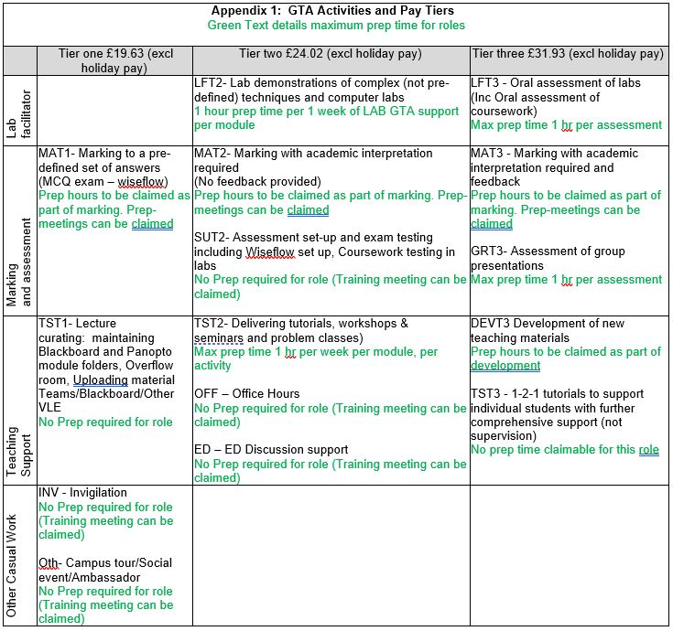

If you have any questions, please do not hesitate to get in touch with the Department’s [casual worker support.](mailto:%20eeecasualworkersupport@imperial.ac.uk)