Mapping the Mantle Zoo: Integrating geodynamics, seismology and mineral physics to characterize Earth’s internal chemical reservoirs

Supervisors: Dr Fred Richards (f.richards19@imperial.ac.uk); Prof Saskia Goes)

Isotopic analysis of igneous rocks erupted at Earth’s surface or emplaced at depth, indicate the existence of several end-member chemical components within Earth’s mantle. While it is agreed that this ‘zoo’ of putative chemical reservoirs must reflect specific evolutionary pathways for generating mantle heterogeneity, which processes control these pathways and where the distinct reservoirs reside remain open questions. Advances in seismology over recent decades have revealed deep mantle structures that could host certain of these chemical species; however, the relative insensitivity of elastic properties to compositional variability makes it difficult to determine the chemistry of these features using seismological observations alone. This project aims to overcome these limitations by integrating geochemical, geodynamic, geodetic, and seismological observations with mineral physics constrained numerical models to determine the most likely location and bulk composition of these reservoirs, as well as the processes responsible for their formation and preservation.
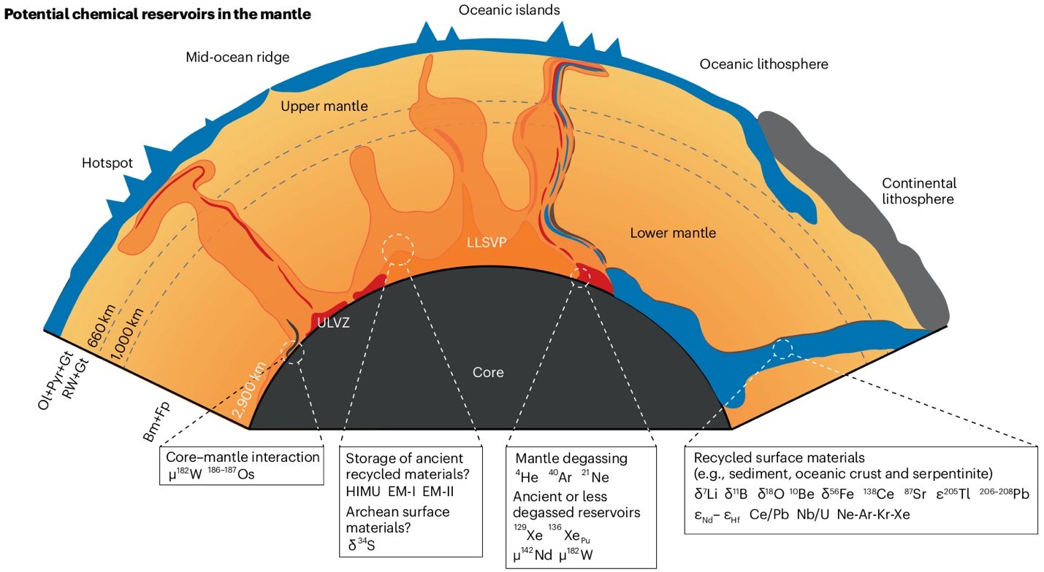

Mantle geochemistry can help to answer fundamental questions about the origins and early evolution of our home planet, since chemical anomalies diffuse slower than thermal counterparts, while compositional viscosity and buoyancy contrasts can prevent their entrainment and dispersal. Indeed, there is compelling isotopic evidence from ocean island basalts (OIBs) that heterogeneities formed in the first ~60 million years of Earth history still survive somewhere in the mantle. However, historically poor constraint on deep mantle mineral properties, combined with strong trade-offs between thermal and compositional sensitivities of seismic velocities, have frustrated efforts to characterize mantle chemistry through inversion of seismological observations. Fortunately, new geodynamic, geodetic, and seismological observations (e.g., dynamic surface and core-mantle boundary topography, body tides, and Stoneley modes), coupled with recent breakthroughs in experimental and computational mineral physics, now provide an opportunity to substantially reduce the non-uniqueness of previous thermochemical inversions.

This project will make use of these developments and innovative machine learning techniques to: i) probabilistically assess the composition of enigmatic seismically imaged mantle structures, including large low velocity provinces (LLVPs) and ultra-low velocity provinces (ULVZs); ii) test the geodynamic feasibility of different proposed mantle structure models (e.g., the BEAMS hypothesis); iii) investigate evidence for systematic chemical differences between individual LLVPs, ULVZs and cratonic roots; iv) develop thermochemical mantle convection models that are consistent with observed isotopic heterogeneity of ocean island basalts. It will suit a numerate scientist with computational experience and an interest in conducting research at the interface between geochemistry and geophysics

