Imperial College London
DEPARTMENT OF AERONAUTICS

PhD Studentship in
“Advanced lightweight metal nanocomposites for the energy transition: interface design and manufacture”

Applications are invited for a fully funded Ph.D. studentship in the field of fabrication and characterisation of lightweight metal composites reinforced by nanocarbon within the Department of Aeronautics at Imperial College London. The project will be led by Dr Qianqian Li (https://www.imperial.ac.uk/people/qianqian.li), an expert in nano-reinforced lightweight metals, and co-supervised by Prof Milo Shaffer (www.imperial.ac.uk/nanostructures-and-composites), an international leader in the chemistry of nanocarbons.

Nanoparticle-reinforced lightweight materials with improved physical and mechanical properties have a wide range of applications. By reducing structural weight, they can improve fuel efficiency, lower emissions, and increase range of electrified or hybrid vehicles. To maximise performance, the characteristics of the nano-reinforcement have to be matched to specific strengthening mechanisms. The selected nanoparticles must then be integrated effectively into a suitable lightweight metal matrix, based on magnesium or aluminium alloys. This PhD project will focus on new nano-interface design, via chemical or physical approaches, to maximise wetting and dispersion. As illustrated by recent work in the group (see Figure), advanced techniques, such as synchrotron X-ray tomography and X-ray transmission microscopy, can quantify 3D dispersion and interfacial interactions. The detailed orientation relations and reinforcing mechanisms operating in the nanoparticle composites will be studied by High Resolution TEM with collaborators in Germany and correlated with modelling approaches. The mechanical properties and other physical properties (including electrical and thermal conductivity) will be measured and related to the nanoparticle system and associated composite microstructure. A new high throughput methodology to accelerate the nanocomposite design process will be explored in collaboration with commercial partners.

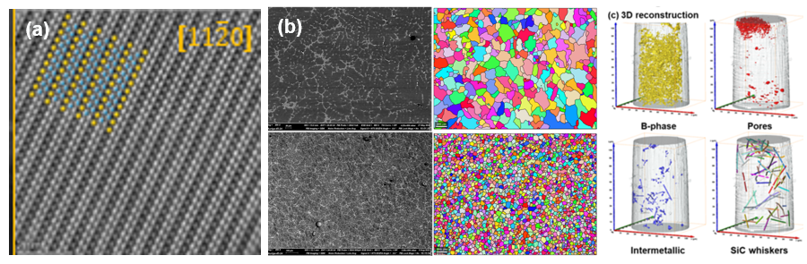
Fig 1 (a) HRTEM of T2-Al₂MgC₂ phase at atomic resolution; (b) SEM/EBSD for 2D phase distribution and nano-SiC dispersion in pure Mg AZ91 and Mg composites; (c) 3D reconstruction of different phase distribution in metal nanocomposites after XCT.

The project will directly benefit from the outstanding synthesis and computational facilities at the Department of Aeronautics, as well as advanced microscopy facilities in the department of Materials Science and nanomaterials chemistry facilities in the newly built £150M Molecular Sciences Research Hub. The project will also benefit from international collaborations with Universities in Germany, France and Switzerland, and will likely involve experiments at central international facilities. The main work location will be the central London South Kensington campus next to Hyde Park offering an excellent setting for the project and for personal development in a variety of areas.
Applicants should have a strong background in materials science and engineering especially in metal materials, good knowledge in chemistry and engineering design, and a keen interest in nanomaterials. A demonstrated ability in independent experimental research is an advantage, particularly any contribution to scientific publication(s). Applications are invited from candidates with (or who expect to gain) a first-class MEng/MSc degree (or equivalent) in Materials Science or Engineering.
The studentship is for 3.5 years and will provide full coverage of tuition fees and an annual tax-free stipend of approximately £20,622 for Home, EU and International students.

Information on fee status can be found at https://www.imperial.ac.uk/study/pg/fees-and-funding/tuition-fees/fee-status/

To apply, please go to http://www.imperial.ac.uk/study/pg/apply/how-to-apply/ Meanwhile please also send your cover letter and CV in one pdf document to Dr. Qianqian Li via e-mail: Qianqian.Li@imperial.ac.uk

Start Date: Asap
Ref: AE0013v3

