Collaboration Kickstarter
Jargon Bin - Key terms and use of language
Imperial College London’s Public Engagement team are launching the Collaboration Kickstarter: a new approach to seed funding engaged research with communities that aims to award funds of up to £10,000 to support Imperial Researchers and Community Partners to do research together and in collaboration.

This document will be updated throughout our pilot to collect examples, and give definitions, of inaccessible language. If there is any language you see or hear when engaging with the Collaboration Kickstarter that you don’t understand, please don’t hesitate to let us know at societal_engagement@imperial.ac.uk and we will make sure a definition is added to this document.

Below is a list of language and terms that have been raised so far in alphabetical order.
Community partners
We hold a deliberately broad definition of “community partner” and ask applicants to simply make the case that your particular partnership is a community partnership that is appropriate, relevant, and will deliver small-scale research activities in line with the aims and principles of the fund in its pilot year.
Engaged Research
When we talk about engaged research or participatory research, we are talking about research that is designed and delivered collaboratively by a mixed group of academic and non-academic researchers (in this case community partners).
This is different from a piece of research where academics collect data from human participants.

In engaged or participatory research, community partners should have a meaningful influence over what questions get asked and how they get answered. This might include:

- Building a shared understanding of what we already know and contributing their expertise to identifying where the gaps are.
- Being a part of collecting data and using it to create new knowledge.
- Having the opportunity to be co-authors and contributing to what gets written about research as well as the language it is written in.
- Deciding where we share learning from research and how it can have an impact in the real world.
Imperial College London
Founded in 1907 with a mission ‘To be useful’, Imperial College London uses science to try to understand more of the universe and improve the lives of more people in it. The research and innovations produced by the College are right now helping to navigate some of the world’s toughest challenges in global health, climate change, Artificial Intelligence (AI), business leadership and more.

Imperial has a greater proportion of world-leading research than any other UK university, according to the Research Excellence Framework.

Imperial College has five core values. They are:

- Respect
- Collaboration
- Integrity
- Innovation
- Excellence

You can read about each of the values in detail here.
Pilot
When we refer to our seed fund as a ‘pilot’ or say that we are ‘piloting’ a new seed fund, we mean that we are testing it out before introducing it more widely. We hope to learn what does and doesn’t work so we can make sure that how we seed fund research in future is fit for purpose.

It is not a given that this fund will continue (decisions around money are going to be internal to Imperial and/or dependent to some extent on allocation of future funding from Research England). That is why we propose building a collection of evidence to justify the value of this work.
Research
(University) research is understood as original investigation undertaken to gain new knowledge and understanding for public benefit.

It is helpful to think of it as trying to answer a general question about the world that we don’t yet know the answer to.
Research council
A research council is an organisation who awards funding that allows research to take place.
UK Research and Innovation (or UKRI) are a group of national research councils that award public funds to researchers and universities.
Research England, who are one of UKRI’s councils, have awarded money from the Participatory Research Fund to Imperial College London and some of this money is being used to pilot the Collaboration Kickstarter.
Research cycle
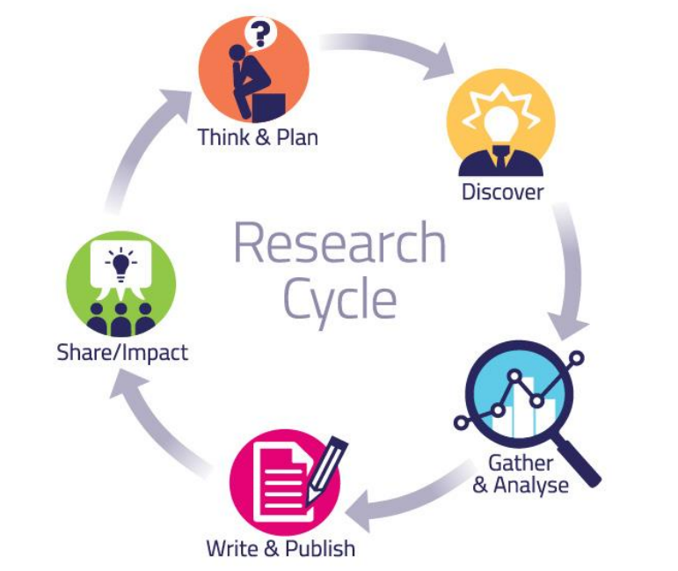
We often think of research as broken down into stages of a cycle.
When we are ‘Thinking and Planning’ we are deciding what questions we would like to know the answers to and what the most appropriate ways are to find those answers. This stage includes planning and designing what a piece of research will look like.

At the ‘Discovery’ stage, we are finding out what is already known about the area we are interested in researching. This involves looking at what research has already been done and seeing where the gaps are in what the research world already knows about a topic.

When we ‘Gather and Analyse’ we collect information that we think will reveal the answer to our question and look through it to see what we have found out.

Then we ‘Write and Publish’ what we have found out before we ‘Share’ what we have learned and try to create an ‘Impact’ in the real world.
Seed Fund
Seed funds award small pots of money to activities (in our case small-scale research projects) that are in their early stages to help them go from an idea to something bigger.
STEMB
The acronym STEMB, refers to the subject areas that Imperial College delivers research in. The letters stand for:

- Science
- Technology
- Engineering
- Maths (and sometimes Medicine)
- Business

The College has four faculties working across these subject areas. These are Engineering, Medicine, Natural Sciences, and the Business School.
You can find out more about our faculties and the departments within them here.

